- The equation to be solved :
- Single components:
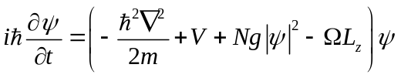
Where 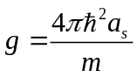,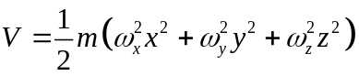,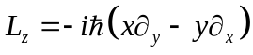
Making transformation:
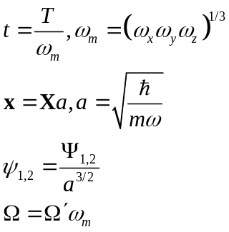
Dimensinless GPE:
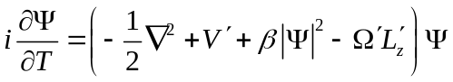
Where 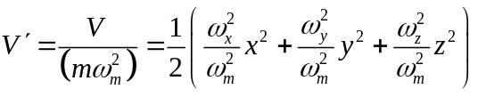,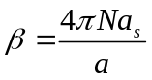,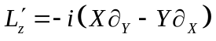

(2) Two components with gravity:
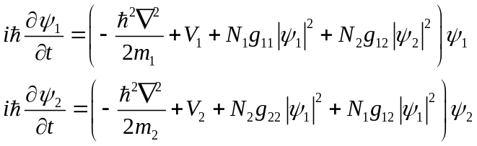
Where
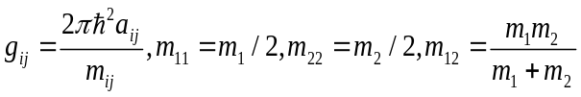
transformation:
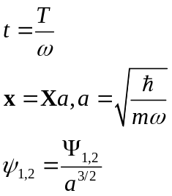
Dimensionless GPE:
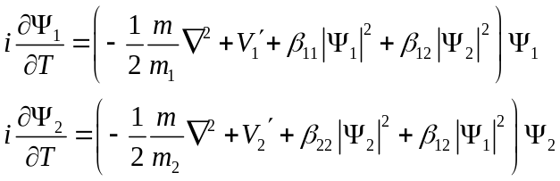
Where
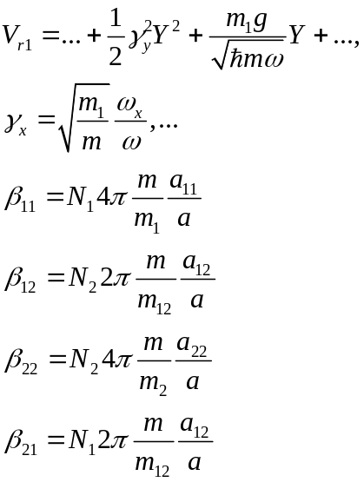
We can choose to be the reduced mass 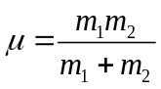 and to be
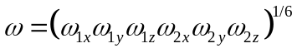

- Procedure to calculation in GPE.
Just follow the example m. file, but some places need to modified.
- The first part is “Setting the method and geometry”, key places:
a) Deltat is the time step in the dynamic calculation; the total number of iteration =Stop_time/ Deltat.
b) Stop_crit is used in the ground state calculation. In some matlab versions, Stop_crit = {'Energy',1e-6}, while in some othter versions, Stop_crit = 1e-6.
c) Nx, Ny, Nz is the grid points number, it must be 2^N+1;
An experience: For 3D calculation, max N may be 2^7+1, then the memory used is ~1.5G.
d) Method and Geometry3D is two “structure”s.
(2) “Setting the physical problem”
a) Physic3D is a structure contain the physical parameters we define, created by Physics3D_Var3d(Method, Delta, Beta). Other functions in this part adds or modifies a field to the structure.
b) The kinetic energy part is defined by Dispersion_Var3d (Method, Physics3D, Dispersion, G), here dispersion is a function which is the Fourier transform of the kinetic part. By default,it is
Dispersion=@(FFTX,FFTY,FFTZ)Physics3D.Delta*(FFTX.^2+FFTY.^2+FFTZ.^2)
Since the Fourier transform of 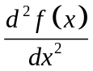 is 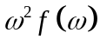.
In two species case, we need to multiply two different constant to the dispersion, this is achieved by defining G as a 2 by 2 matrix, 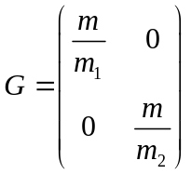.

c) The potential is defined by Potential_Var3d(Method, Physics3D, Potential, G).
In two species case, Potential is a “cell”, with the two potential functions in the diagonal elements.
For a time-of-flight calculation (Dynamic), the potential is defined by TimePotential_Var3D (Method, Physics3D, @(t,x,y,z) 0)
An experience: the zero point of the potential function must near zero, otherwise the calculation is poor.

d) The mean field part is defined by Nonlinearity_Var3d(Method, Physics3D, Nonlinearity, G, Nonlinearity_energy).
Here Nonlinearity and Nonlinearity_energy are “cell”s. The defined functions are in the diagonal elements.

Notes: for c) and d) when we need the non-diagonal elements?
In general, GPELab solve the equations
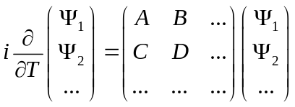
In the two BEC case, 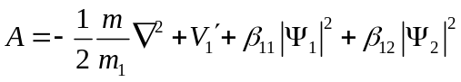,
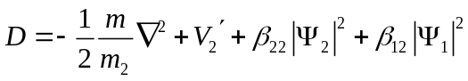, 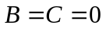.
Hence the relevance terms are in the diagonal elements of the cells. In some physical problems B and C can be nonzero, then we should define the corresponding terms. For example, in the problems of spinor BEC or spin-orbit coupled BEC.

(3) “Setting the initial data”
InitialData_Choice = 1 : Gaussian function;
InitialData_Choice =2 : Thoms-Fermi wavefunction;
User defined initial function can be defined by Phi_0= a three dimensional matrix.
In a time-of-flight calculation, this correspond to the in-trap solution.

(4) “Setting informations and outputs”
Evo_outputs is the iteration step to save the solution, e.g., Evo_outputs=100 means save the solution every 100 iterations. Evo =100 means show the solution on screen every 100 iterations. Evo_outputs must<=Evo.

(5) “Launching simulation”
by [Phi, Outputs] = GPELab3d(Phi_0,Method,Geometry3D,Physics3D,Outputs,[],Print);
Then the output result is: Phi is a cell contains the final wavefunctions. Phi{1} is the 3D matrix of the first wavefunction, Phi{2} is the second. Outputs is a structure contains the information of the calculation. The i-th saved wavefunctions during iterations is Outputs.Solution{i}{1}.

3. Dealing with the 3D matrix
We have to deal with 3D matrix since the solutions are these with complex elements. I write a few functions to do this.
save3Ddata(path, matrix) save a 3D matrix into a file(.txt) at “path”, in the form of a 2D matrix.
read3Ddata(file) read the file saved by the above function, and reshape the 2D matrix into a 3D matrix then output it.
Expandmatrix(file,N) read the file and reshape to 3D matrix, then expand the matrix into N*N*N element, with the original matrix in the center and zeros at the outside.
ReduceMatrix(matrix,N) reduce matrix to N*N*N elements, with uniform sampling.
ReduceFileAndSave(file,N) reduce the file to N*N*N matrix by the above function, and save it to a new file with additional string ‘rd’ in the file name.
Saveintrap(Geometry3D,Phi,N) save the wavefunctions, denities, expanded wavefunctions and densities, the coordinate matrix of x, y, z into the folder “dataintrap”.
Savetof(Geometry3D,Outputs,Deltat,Evo_outputs) save the wavefunctions, denities at each time-of-flight (=Deltat* Evo_outputs), the coordinate matrix of x, y, z into the folder “datatof”, and save the center of mass positions.
PlotColumndensity(file,x,y,z) plot the column density of the 3D matrix save in “file”, with x, y, z are the files saving the 3D matrix of coordinates of x,y,z.
PlotColumndensity_intrap(path) plot the column density of the solutions saved in “path”. It must be used when the current folder is outside the folder of “path”.
PlotColumndensity_tof(path,t) plot the column density of the solutions saved in “path”, with time-of-flight=t. It must be used when the current folder is outside the folder of “path”.

To make it convenient, in the two BEC case, a “setparameters.m” file is written, which contains all the parameters needed to change. The functions above are used in the “TBEC_Intrap.m” and “TBEC_TOF.m”. So the sequence is
1. Set the current folder as ‘…\TBEC3D’, and make sure the two folder ‘dataintarp’ and ‘datatof’ exist;
2. Modify the parameters in “setparameters.m” and save;
3. Run “TBEC_Intrap.m”;
4. Run “TBEC_TOF.m”;
(Make sure the current folder is right, otherwise the save and plotcolumndensity does not work.)

